**Stroop effect project**

1. In this project we will study Stroop effect based on a dataset.

Independent variable is type of task: congruent or incongruent task.

*In the* congruent words*task, the words being displayed are color words whose names match the colors in which they are printed: for example, RED, BLUE.*

*In the* incongruent words*task, the words displayed are color words whose names do not match the colors in which they are printed: for example, PURPLE, ORANGE.*

Dependent variable is number of seconds needed to a participant to name colors of ink in which words in a list are printed.

1. We will test following hypotheses:

H0: Number of seconds needed to name colors for a list of words is the same with congruent and incongruent words.

HA: Number of seconds needed to name colors for a list of incongruent words is greater than number of seconds needed to name colors for a list of congruent words.

These hypotheses reflect the description of Stroop effect which confirmation we are looking for. According to the Stroop effect it takes longer to name the color of a word that doesn’t match the color in which it is printed than to name the color of a word that matches the color in which it is printed. We will test the null hypothesis that rejects the existence of Stroop effect against the alternative hypothesis which confirms the existence of Stroop effect.

The appropriate statistical test to perform in that case is t-test as we don’t know the entire population mean, nor the standard deviation. We will conduct one-tailed test as the hypothesis we’re testing is that the interference (incongruent condition) makes people read the list slower, not faster. Also, we have paired data: the two samples are dependent because the same individual has taken the test twice under two different conditions.

That is why we can analyze data representing the difference between congruent task time and incongruent task time.

1. Here are some descriptive statistics regarding a dataset representing time needed to read a list of words with congruent and incongruent condition (in sec) for 24 participants.

Dataset size: 24

|  |  |  |  |
| --- | --- | --- | --- |
|  | Congruent task (sec) | Incongruent task (sec) | Difference (sec) |
|  |  |  |  |
| ***Median*** | 14.36 | 21.02 | 7.67 |
| ***Mean*** | 14.05 | 22.02 | 7.96 |
| ***Standard deviation*** | 3.56 | 4.80 | 4.86 |
| ***Range*** | 13.70 | 19.57 | 19.97 |
| ***Q1*** | 11.71 | 18.69 | 3.56 |
| ***Q3*** | 16.40 | 24.21 | 10.49 |
| ***IQR*** | 4.69 | 5.52 | 6.93 |
| ***Outlier has to be less than:*** | 4.68 | 10.42 | -6.82 |
| ***Outlier has to be greater than:*** | 23.90 | 33.04 | 21.57 |

We can see that congruent task median and mean are lower than incongruent task median and mean and standard deviation is lower for congruent task than for incongruent task which means that congruent task data are less spread around the median. There are no outliers for congruent task data and there are 2 outliers (greater than 33.04: 34.29 sec. and 35.26 sec.) for incongruent task data. If we consider the distribution of differences between time needed for congruent and incongruent task for same individuals, we notice that median difference is 7.67 sec and there is one outlier (greater than 21.57: 21.92 sec.)

The range and IQR are greater for incongruent task and difference; in other words, these data are more spread out. Based on this sample we could say that tested individuals, though all of them were disturbed by the incongruent condition, reacted differently to the interference.

1. Here are two histograms representing sample data distribution (x-axis values are in seconds):

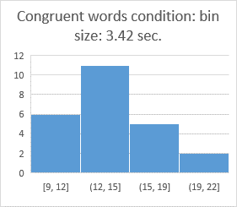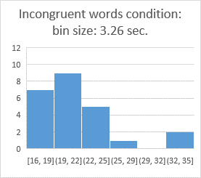

We can notice that both datasets are positively skewed with two outliers for the incongruent words condition dataset. Most frequent time is around 13.5 sec. for the congruent words condition and 20.5 sec for incongruent condition. Most of individuals needed less than 19 sec. to read the congruent words list and less than 25 sec. to read the incongruent words list.

The distribution of differences between tasks is also positively skewed. Most of individuals’ interference was less than 14 sec.: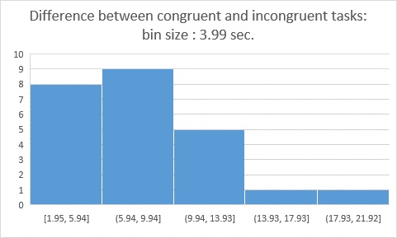

Here are boxplots illustrating datasets distributions:

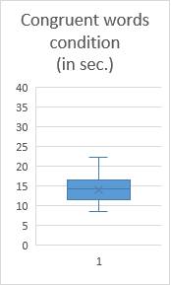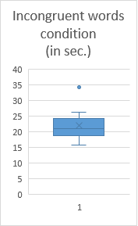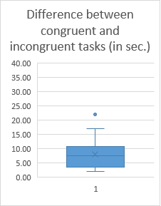

1. Hypothesis test.

H0: µI - µC = 0 (where µI is the mean for incongruent task and µC is the mean for congruent task)

HA: µI - µC > 0 (where µI is the mean for incongruent task and µC is the mean for incongruent task)

We will use confidence level of 95%.

*Calculation details:*

*Our point estimate for difference is 7.96.*

*Sample standard deviation for difference is 4.86.*

*SE = SD/sqrt(n) = 4.86/sqrt(24) = 0.99*

*t-statistic = 7.96/0.99 = 8.04*

*t critical value at α level 5% and 23 df = 1.714*

Test results at alpha level 5%:

* Type of test: dependent samples test
* Test statistic: t-statistic
* Degrees of freedom: 23
* P-value: less than 0.00005
* Direction of test: one-tailed in + direction (because we defined the difference as incongruent task time minus congruent task time)
* Results: t(23) = 8.04, p = 0.00005
* Confidence interval on the mean difference; CI at 95% = (5.91, 10.00)

Conclusions: The results of the test are extremely statistically significant. We can reject the null hypothesis as t-statistic is greater than t critical vale at 5% alpha level.

In other words, people need more time to name colors of incongruent words than to name colors of congruent words. As it was an experiment, we can conclude that there is a causality. The incongruent words condition causes a greater time for naming colors of words. We obtained the confirmation of Stroop effect. That is what was expected.

Also, we can say with 95% confidence that the mean time difference for the entire population is between 6.26 and 9.66 sec.

1. The explanation for Stroop effect is “the ability of most people to read words more quickly and automatically than they can name colors” (De Young, 2014). The delay in naming colors is explained by “the interference that automatic processing of words has on the more mentally effortful task of just naming the ink color” (De Young, 2014). We can imagine that different individuals have different ability to direct their attention to one task over another. For example, according to a Canadian study (NIH, 2012) bilingual children are better at switching between multiple tasks. Comparing Stroop effect on bilingual individuals with Stroop effect on monolingual individuals would be interesting.

Also, other similar tests could be conducted.

For example, showing pictures of animals with a word on top of it designating another animal. The tested individual has to name the animal showed on the picture.

Another test could be conducted with bilingual individuals: the same as test with colors’ names but the word is written in one language and the tested individual has to name the color of ink in which the word is printed in another language. We could see how strong is one language compare to another.

References

Stroop, J. Ridley. (1935). Studies of interference in serial verbal reactions.  
  
          Journal of Experimental Psychology, 18, 643-662.

De Young, R. (2014). Using the Stroop effect to test our capacity to direct attention: A tool for

navigating urgent transitions. Retrieved from <http://www.snre.umich.edu/eplab/demos/st0/stroopdesc.html>

NIH/National Institute of Child Health and Human Development. (2012, April 3). Bilingual

children switch tasks faster than speakers of a single language. ScienceDaily. Retrieved February 24, 2017 from www.sciencedaily.com/releases/2012/04/120403112006.htm